**Types of Banks in the US Banking System: A Comprehensive Guide**

**(Presented By Alan Stuart K)**

**Introduction:**

The US banking system boasts a diverse landscape of financial institutions catering to various needs and financial activities. Understanding these different types of banks can empower you to make informed decisions about your finances. This paper explores the key types of banks in the USA, highlighting their functions, target markets, and unique characteristics.

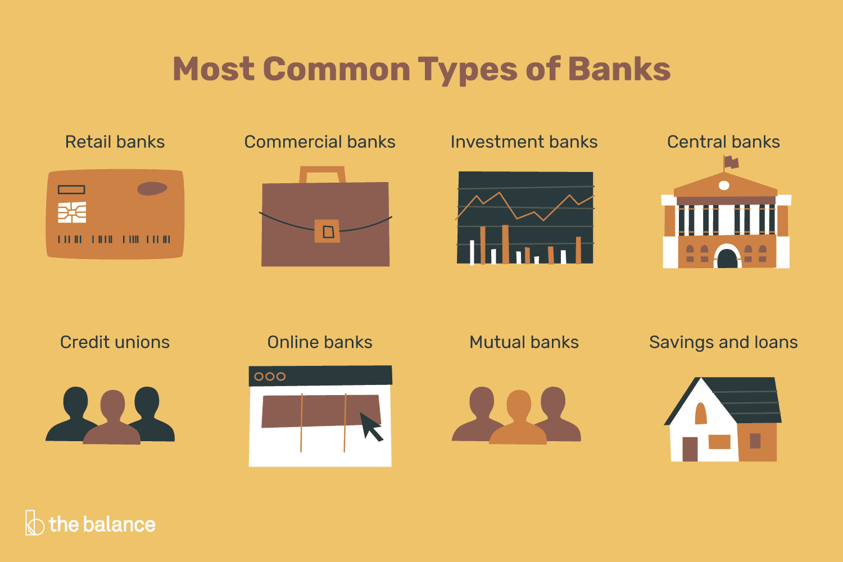

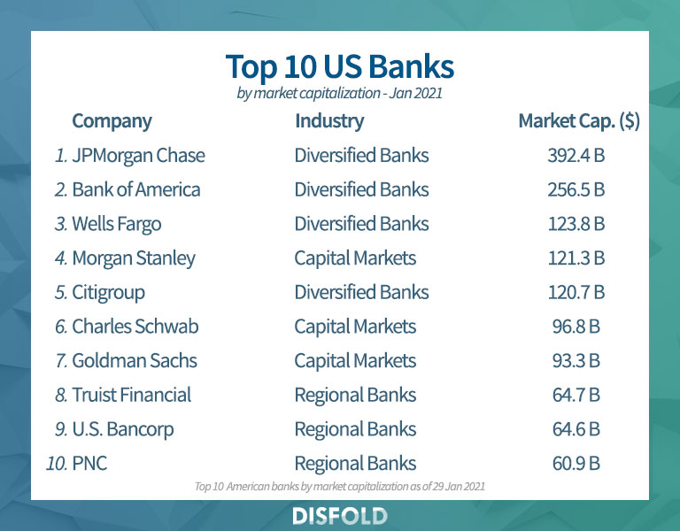

**1. Commercial Banks:**

* **Description:** These are the most common type of bank, often referred to as "retail banks." They offer a broad range of financial services to individuals and businesses, including:
  + Accepting deposits (checking, savings, money market accounts)
  + Providing loans (mortgages, auto loans, personal loans, business loans)
  + Offering cash management services
  + Processing payments
* **Some Stats:** While data availability for the exact number of commercial banks in the USA can vary by source, the Federal Deposit Insurance Corporation (FDIC) reported insuring over 4,800 commercial banks in 2023 [FDIC, The Banks of the United States, 2023].
* **Target Market:** Commercial banks serve a wide range of customers, from individuals and families to small and medium-sized businesses (SMBs).

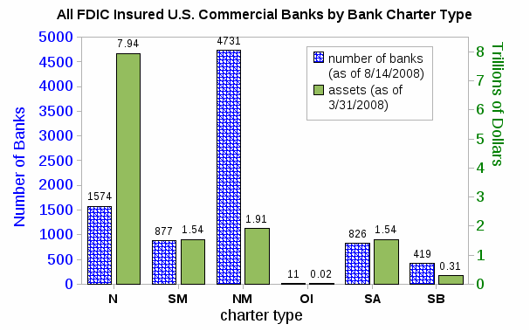

**2. Investment Banks:**

* **Description:** These specialized institutions focus on raising capital for businesses and governments. Their primary services include:
  + Underwriting and selling securities (stocks, bonds)
  + Mergers and acquisitions advisory
  + Wealth management for high-net-worth individuals
* **Some Stats:** The number of investment banks in the USA is significantly smaller compared to commercial banks. A report by Statista in 2023 estimated around 70 investment banking firms operating in the United States [Statista, Number of investment banking firms in the United States from 2008 to 2023, accessed June 5, 2024].
* **Target Market:** Investment banks primarily serve corporations, governments, and institutional investors.

**3. Credit Unions:**

* **Description:** These non-profit financial cooperatives are owned by their members (depositors). Credit unions offer similar services to commercial banks, including:
  + Checking and savings accounts
  + Loans (mortgages, auto loans, personal loans)
  + Online banking services
* **Some Stats:** According to the National Credit Union Administration (NCUA), there were over 5,600 credit unions operating in the USA in 2023 [National Credit Union Administration, About Credit Unions, accessed June 5, 2024].
* **Target Market:** Credit unions typically serve specific communities or groups based on location, profession, or other affiliations. They may offer lower interest rates on loans and higher returns on savings accounts compared to commercial banks.

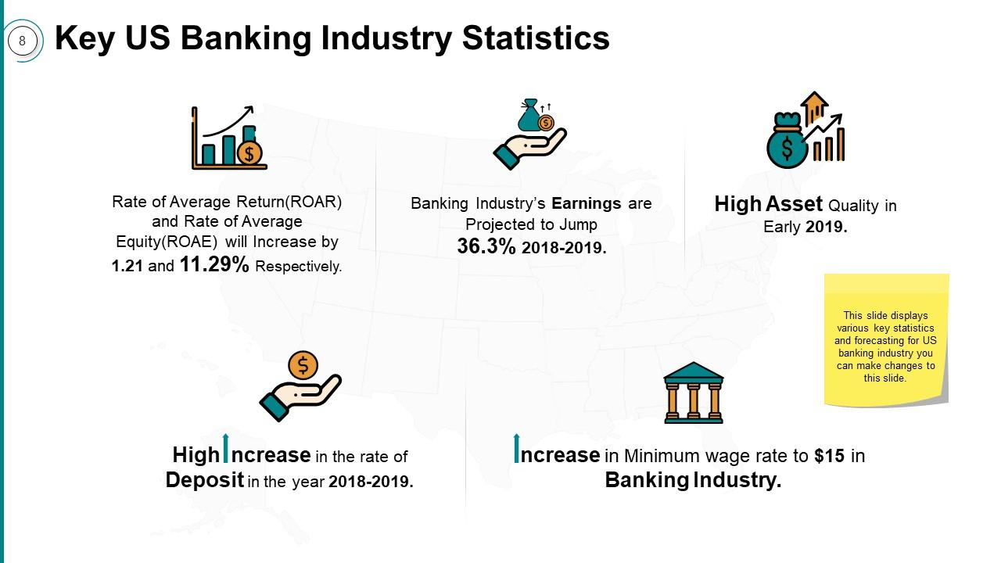

**4. Community Banks:**

* **Description:** These smaller financial institutions focus on serving the needs of their local communities. They often prioritize personalized service and relationship banking. Their services may include:
  + Deposit accounts (checking, savings)
  + Small business loans
  + Consumer loans (mortgages, auto loans)
* **Some Stats:** The exact number of community banks in the USA is challenging to define due to varying criteria. However, the FDIC estimates that community banks account for a significant portion of all insured institutions [FDIC, Community Banking, accessed June 5, 2024].
* **Target Market:** Community banks primarily serve individuals, families, and small businesses within their local geographic area. They often have a deep understanding of the local economic climate and can offer tailored financial solutions.

**5. Savings and Loan Associations (S&Ls):**

* **Description:** Traditionally, S&Ls focused on providing mortgages and accepting savings deposits. However, due to deregulation and financial crises, many S&Ls have converted to commercial banks or merged with other institutions. Some S&Ls may still exist and offer similar services.

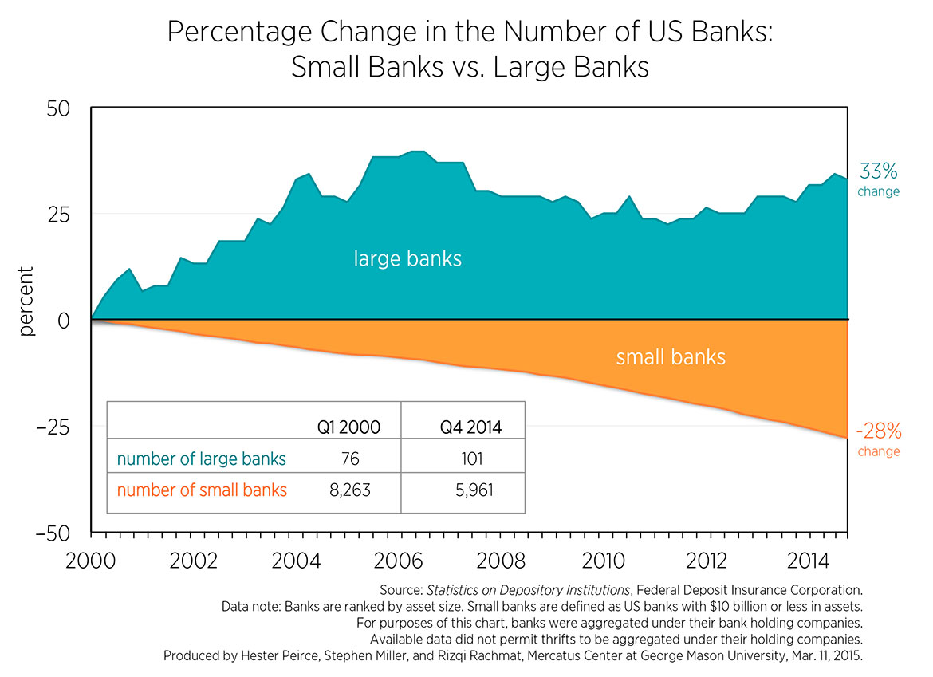

**6. Online Banks:**

* **Description:** These internet-only banks offer a variety of financial services entirely through their online platforms or mobile apps. They typically have lower overhead costs compared to traditional brick-and-mortar banks, often translating into higher interest rates on savings accounts and potentially lower fees.
* **Some Stats:** The number of online banks in the USA is growing rapidly. A report by The Financial Brand in 2022 estimated over 200 online banks operating in the United States [The Financial Brand, How Many Online Banks Are There in the United States, accessed June 5, 2024].
* **Target Market:** Online banks appeal to tech-savvy consumers who value convenience and potentially lower fees.

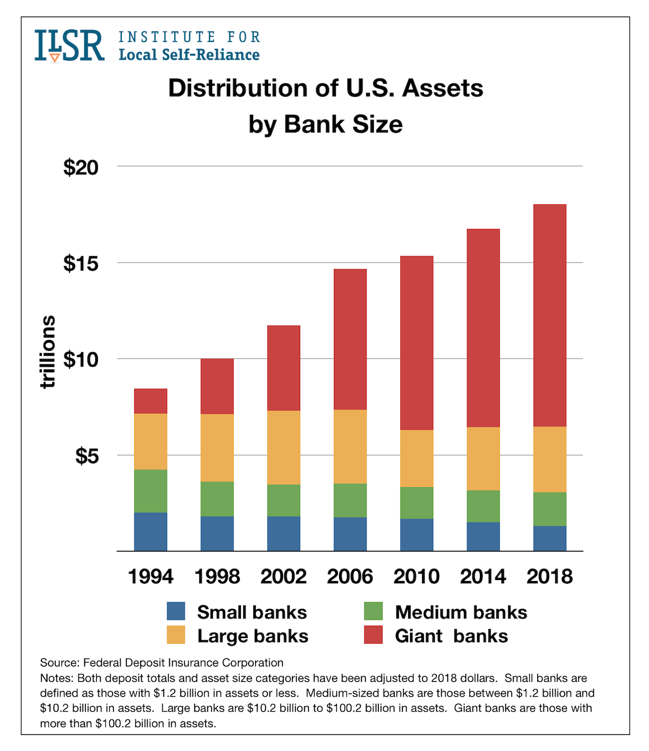

**7. Fintech Companies:**

* **Description:** These are not technically banks but utilize technology to provide financial services. Fintech companies often disrupt traditional banking models by offering innovative solutions, such as:
  + Mobile payment platforms (e.g., Apple Pay, Venmo)
  + Peer-to-peer lending platforms
  + Online investment and wealth management services
  + Blockchain-based financial products
* **Some Stats:** The Fintech industry is rapidly evolving, making it challenging to pinpoint the exact number of companies. However, a report by Statista in 2024 estimated that the global Fintech market size surpassed $127 billion [Statista, Fintech market size worldwide from 2018 to 2027 (in billion U.S. dollars), accessed June 5, 2024].
* **Target Market:** Fintech companies cater to a wide range of consumers, particularly those seeking convenient and technology-driven financial solutions.

**8. Central Bank: The Federal Reserve:**

* **Description:** While not a bank in the traditional sense, the Federal Reserve System (the Fed) acts as the central bank of the United States. It plays a critical role in:
  + Conducting monetary policy (interest rates, money supply)
  + Regulating banks and other financial institutions
  + Providing financial services to the US government
* **Some Stats:** The Federal Reserve is a single entity with 12 regional Federal Reserve Banks located throughout the USA.

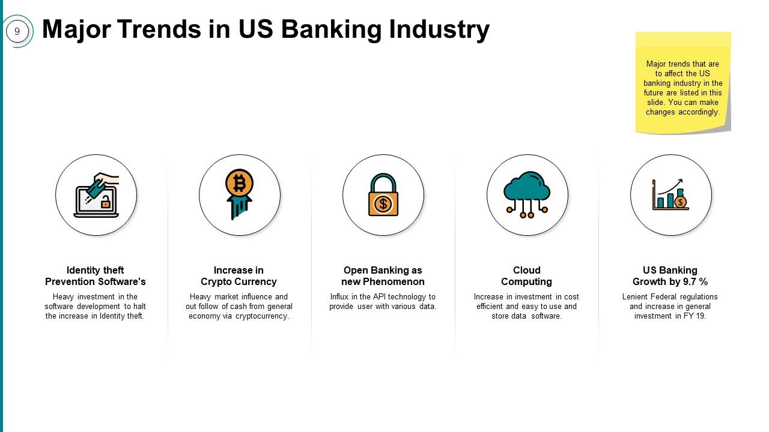

**Conclusion:**

The US banking system offers a variety of institutions to serve diverse financial needs. Understanding the different types of banks can empower you to make informed decisions about your finances. Consider your individual requirements and conduct research to choose the bank that best aligns with your goals and preferences.

